**MATRICES & DETERMINANTS**

**Trace of the Matrix**

* Sum of **diagonal values** of the matrix.
* Applicable on **square matrices** only.
* Denoted by ***tr(A)*** for matrix ***A***.

**For example:**

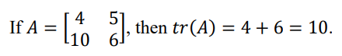

**Symmetric Matrix**

**A = AT**

* ***AT*** is called ***transpose*** of matrix.
* Applicable on **square matrices** only.

**For example:**

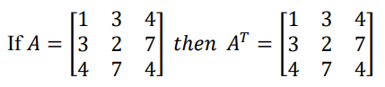

**Skew-Symmetric Matrix**

**A = -AT**

**Singular & Non-Singular Matrix**

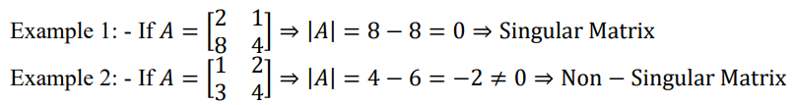

**Orthogonal Matrix**

**AAT = I**

* ***I*** is identity matrix.

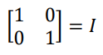

**System of Linear Equations**

* **Unique solution:** Two lines **intersect** at some point (***consistent***).
* **No solution:** Two lines are **parallel** to each other (***inconsistent***).
* **Infinitely many solutions:** Two lines **coincide** on each other (***consistent***).

**Augmented Matrix**

* Linear equations written in form of matrix.

**For example:**

**2x1 + 2x3 = 1**

**3x1 – x2 + 4x3 = 7**

**6x1 + x2 – x3 = 0**

**These can be represented as:-**

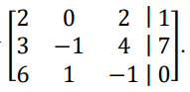

**Non-Homogeneous Matrix Solutions**

* For ***no solution***, all the **variable elements** for one of the row are **zero** & **constant** element is **non-zero**.

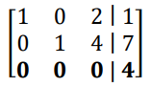

* For **infinitely many solutions**, all the **variable elements** as well as the **constant element** are **zero**.

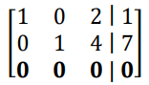

* For **unique solution**, all the rows contain their **leading 1**.

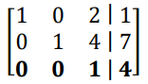

**Row Echelon (RE)**

* **Rule 1:** All the first **non-zero** elements in each row must be **1**.
* **Rule 2:** Below **leading 1s**, there must be nothing other than **0s**.
* **Rule 3:** Complete **zero** rows must be below rows with leading **1s**.

**Reduce Row Echelon (RRE)**

* **Rule 1 + Rule 2 + Rule 3 + Rule 4**
* **Rule 4:** All entries other than leading **1s** are **0**.

**Solving System of Linear Equations**

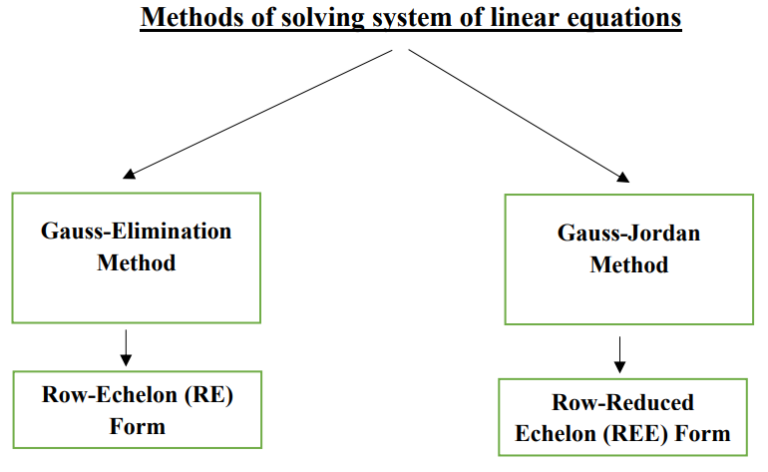

General way of **representation**:-

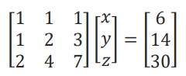 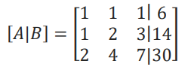

**Gauss Elimination Method**

* **Step 1:** The **RE** is written in form of linear equations.
* **Step 2:** Now the values of variables are identified by **substitution**.

**Gauss Jordan Method**

* **Step 1:** The **RRE** is written in form of **linear equations**.
* **Step 2:** An **arbitrary value** is used for a **variable** used commonly in equations.
* **Step 3:** And that’s the form they are written at last.

**For example:**

**Equations obtained from RE form,**

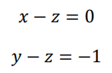

**Assuming common z as t,**

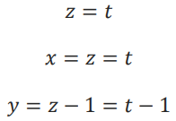

**And this is also done in case of *unique solution*.**

**Homogeneous Equations**

**AX = 0**

* Meaning that the matrix gives **trivial solution**.
* **Trivial solution:** When all solutions of variables are **zero**.
* **A** is the ***main matrix*** & **X** is the ***variable matrix***.
* ***Homogeneous matrices*** are always **consistent**.

**For example:**

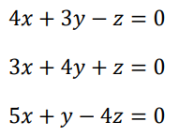 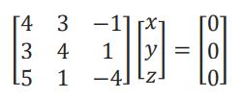

**X’s dimension = c*1**

**Constant matrix’s dimension = r*1**

**Rank of Matrix**

* Represented by ***r*** or ***p(A)***.
* Applicable on **square matrices** only.
* There exists **at least one** minor of order ***r***.
* Every **minor** of order greater than ***r*** is **zero**.

**For two given matrices A & B,**

**[p(AB) <= p(A)] or [p(AB) <= p(B)]**

For finding rank of a matrix:-

* **Step 1:** Start **finding** **determinant** from highest possible order.
* **Step 2:** If that is **zero**, start **decreasing** the order by **1** & find all possible **minors**.
* **Step 3:** The ***rank*** is equivalent to order with a **non-zero minor**.

**Example 1:**

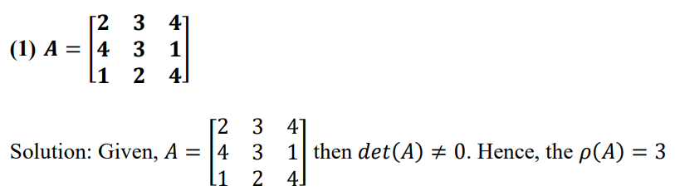

**Example 2:**

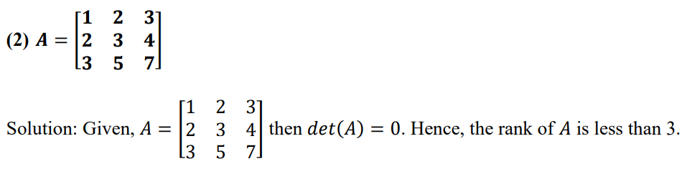

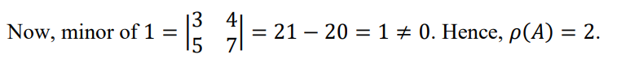

* Using the **row-echelon** form will make it **easier** to find the ***rank***.

**Eigen Values & Eigen Vectors**

**AX = λX**

* **λ** is called ***eigen value/ characteristic value/ real value***.
* **X** is called ***eigen vector/ characteristic vector/ real vector***.
* ***Eigen vector*** can **never** be ***zero vector***.

**Characteristic eqn,**

**=> det(A – λIn) = 0**

**=> |A - λIn| = 0**

* **Root** of this equation is known as ***characteristic value/ root value*** i.e. **λ**.
* Applicable on **square matrices** only.

Types of eigen values:-

* **Non-repeated**.
* **Repeated** with **non-symmetric** matrix.
* **Repeated** with **symmetric matrix**.

**Algebraic & Geometric Multiplicity**

* **Algebraic multiplicity:** The number of times an ***eigen value*** appears as **root**.
* **Geometric multiplicity:** The number of **complete zero** rows an ***eigen value*** gives, when put in the ***characteristic matrix***.

**Eigen Space**

**For example:**

**Suppose this matrix,**

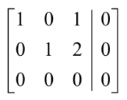

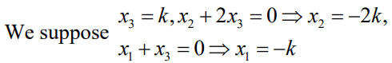

**Hence the eigen space,**



**And for writing *eigen spaces* for a matrix with separate *eigen values* together,**



**Alternative Matrix Representation**

* Every matrix can be represented as **sum** of **symmetric** & **skew-symmetric** matrices.

**A = 0.5 (A + AT) + 0.5 (A – AT)**

**Where, 0.5 (A + AT) as a whole is *symmetric*.**

**And, 0.5 (A – AT) as a whole is *skew-symmetric*.**

**Caley-Hamilton Theorem**

* This theorem says that, each ***square matrix*** satisfies itself as an ***eigen value***.

**For example:**

**Given matrix:**

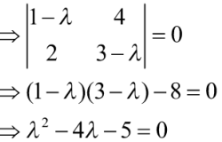

**Putting matrix as an *eigen value*:**





**Inverse of a Matrix**

**A-1 = (1/|A|) A**

**Diagonalization of Matrix**

* Purpose of ***diagonalization*** is to **simplify** the matrix for calculations.

**D = P-1AP**

**Here, *P* is a matrix with values of *eigen spaces* put column-wise.**

**For example:**

**Given matrix:**

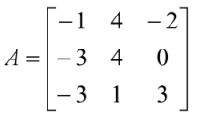



**Eigen spaces:**







**Thus,**

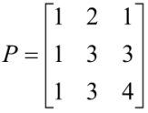

**Also,**

**A = P-1DP**

**Quadratic Forms**

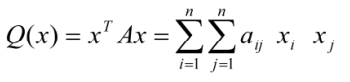

* Representing **quadratic equations** in form of **matrix** & vice-versa.
* Uses two popular types of **quadratic equations**.

**Quadratic eqn type I:**

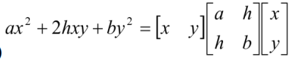

**Quadratic eqn type II:**

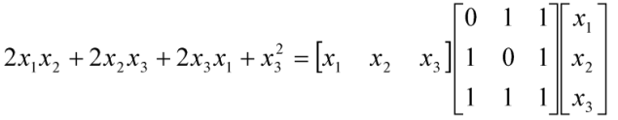

**Quadratic to Canonical Form Conversion**

**For example:**

**Step 1: Get the equation.**



**Step 2: Convert it to the relevant quadratic matrix.**

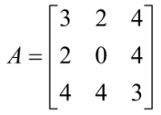

**Step 3: Fetch the eigen values.**



**Step 4: Convert the equation to canonical form.**

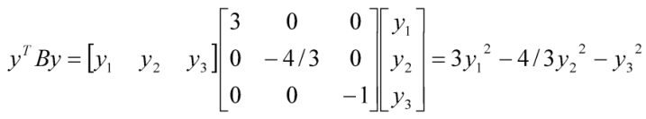

**Nature of Quadratic Form Q**

* **Positive definite:** All the eigenvalues of matrix are **positive**.
* **Negative definite**
* **Indefinite:** **Positive** & **negative** eigen values coexist.
* **Semi-positive definite**
* **Semi-negative definite**